**Terraform Task-2**

Create 2 EC2 instances on 2 different regions and install nginx using terraform script.

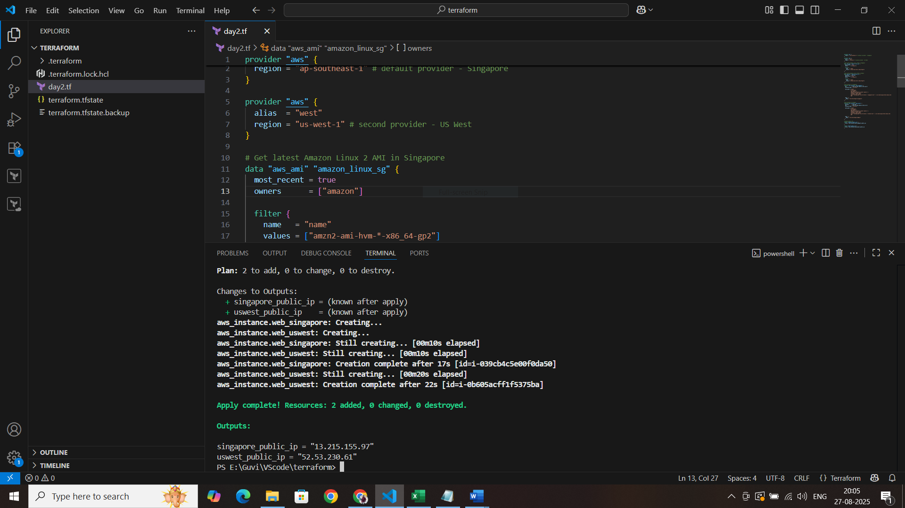

**EC2-Region-1 and nginx installed**

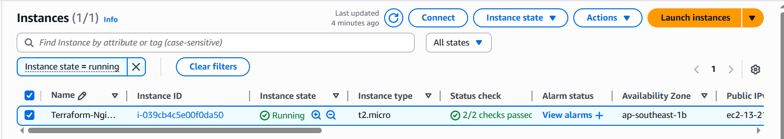



**EC2-Region-2 and nginx installed**

